Trade Modification Detail Design & Change

Requirements from Operation Toolkit 1.0 (Trade Modification)
Occasionally, errors in the market maker profile cause trades to be assigned to a clearing firm where the clearing will fail. When this occurs, the Help Desk requires a screen from which specific, authorized users can modify the trade. From this tool, the help desk will be able to search for a specific trade. Once the trade is selected, the Help Desk should be able to edit the executing/give-up firm and exchange and the market maker acronym and exchange. Price and quantity fields cannot be changed. Once the edit is saved, CBOEdirect should send CTM the modified trade. When this occurs, no new last sale should be disseminated via CFN. The trade history record should have an indication that the Help Desk modified the trade.

Summary of Requirement & Design
1) There will be no new query method needs to add, Help Desk will use the current query method (getTradeReportV2ByTradeId ) to query by giving trade Id, the trade Id will be tracked by the user.
Note: After talking with Ravi V and Brad Sh., only the current nonV2 method will be called by SBT Trade modification, e.g. getTradeReportByTradeId

2) The to be updated fields are
a) Broker Acronym, and exchange for seller side or buyer side in trade report.
b) Firm number and exchange of buyer or seller in trade report.

3) No validation on server side are required for all of the updated fields, except that the input firm & broker information needs to be validated as an existing firm & user, besides this, the update data entered by user will be considered as valid by the system.

4) Trade Modification requires publish the new trade report to CTM to clear,

5) The Trade Modification implementation will be in a new development branch off from the latest SBT_DEV, after it is merged back to dev, Stock code branch will be re-based to the new baseline in DEV and create its own work branch, to complete the implementation and test for DOE recall. In this way Trade modification and DOE recall scrums should be able to share the common code.

6) Persists trade reports for the updated trade.
In Trade Report Entry table, server will:
#1 Mark the current atomic trade report as inactive, update its last entry type with D (delete) and last entry time with current time;
#2 Create a delete inactive atomic report for the inactive report created in step #1
#3 create a new atomic report with the new update information to replace the deleted atomic trade entry.

In Trade History table, server will create a history entry with UPDATE_EVENT 'M' (Modification) for this trade modification entry.

7) Event Channel
The system needs to generate a trade report update event and publish the event to CTM to clear, which means to create a new event method in TradeReport channel.

8) CTMAdapter
Talked to Eric F.(the original designer for that part of code), and reviewed the code together, we believe CtmAdatper will handle the new trade modification event as the other existing event, as long as this new event only contain atomic report with existing report entry types, e.g. D(elete) or A(dd), CtmAdapter will be able to process it without doing any change in the message formatting/processing.

IDL change

1) in TradeMaintenanceService.idl, add a new update method in TradeMaintenanceService
void acceptTradeUpdate
(in cmiSession::TradingSessionName tradingSessionName,
in cmiProduct::ProductKey productKey,
in cmiUtil::CboeIdStruct tradeId,
in trade::AtomicTradeStructSequence atomicTrades)
raises (exceptions::SystemException,
exceptions::CommunicationException,
exceptions::AuthorizationException,
exceptions::DataValidationException,
exceptions::NotAcceptedException,
exceptions::TransactionFailedException);

Notes: This method will not return the changed report after update, because sever will put a trade update request into command queue to get synchronized call, which will be scheduled by its trading class

2) in internalConsumers.idl, add new update event in TradeReportConsumer
void acceptTradeUpdateReport(in util::RoutingParameterStruct routingParams,
in long sourceGroup,
in trade::TradeReportStruct currentTradeReport,
in trade::AtomicTradeStructSequence updates,
in trade::TradeReportSettlementStruct settlementTradeReport);

Notes:
- The consumer of this event needs to apply filter on routingParams .productType and routingParams.groups

- This new event adopts the new routing parameter struct which including all the routing /filer information it needs ( productType, sessionName and classKey), we put sourceGroup to identified the unique groupKey from which the event is published, so that the consumer will able to know the information and fill the unique group into the destination groups of the acknowledgement event of (TradeReportAdmin)

Code Change list

Domain interfaces: /domain/Java/interfaces/com/cboe/interfaces/domain/TradeReport .java
Domain impl: /domain/Java/implscom/cboe/domain/util/StructBuilder.java

Server interfaces: /server/Java/interfaces/com/cboe/interfaces/internalBusinessServices/TradeMaintenanceServiceLocal.java

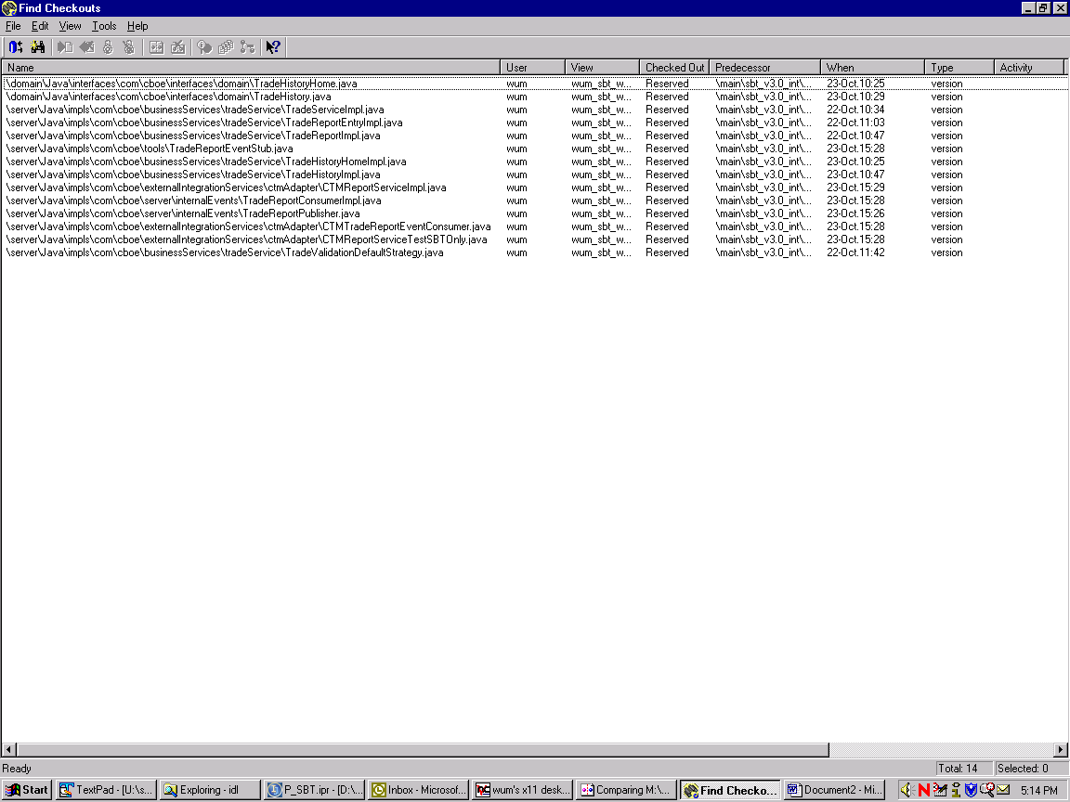

Open issues:

- Need a server Test Environment to do unit test in the working branch.
- Might need to add more modification logic and validation logic if the requirement is changed.

